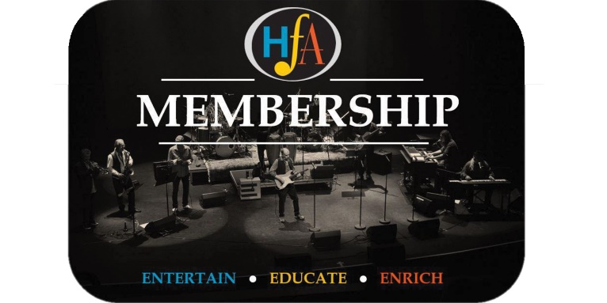
CURRENT MEMBER PROMOTIONS

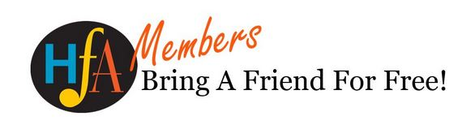
One of the incredible benefits of your membership is that you get to treat a friend, as your own personal guest, to upcoming shows and events. Please take advantage of this benefit for any of the following presentations:
Kyung-A Lee
Taktikz Hip Hop
Queer Songbook Orchestra
Remembering Ed Bickert
To book your tickets just call the Algonquin Theatre Box Office at 705-789-4975 or visit in person. And don't worry! If you have already purchased tickets for these events but would like to take advantage of the Bring A Friend program, you can simply return the tickets and access the deal now. Please note that tickets purchased using the Bring A Friend program are issued at full price.

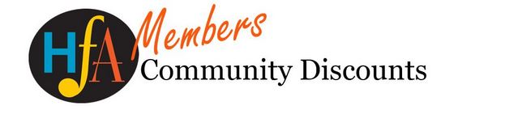
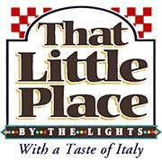
Your membership also includes exclusive discounts at partner businesses!
Over the summer we'll be announcing some great perks at local businesses.That Little Place by the Lights is offering HFA members free Gelato with purchase of a dinner entree. To take advantage, just show your membership card, and you'll get some tasty Gelato!

